**Team ID:PNT2022TMlD50173**

In [19]:

**from** google.colab **import** drive

drive**.**mount('/content/drive')

Drive already mounted at /content/drive; to attempt to forcibly remount, call drive.mount("/content/drive", force_remount=True).

In [ ]:

In [41]:

**import** cv2

**import** numpy **as** np

**from** google.colab.patches **import** cv2_imshow

**from** matplotlib **import** pyplot **as** plt

**import** librosa

**from** matplotlib **import** pyplot **as** plt

**from** PIL **import** Image

*#import load model from keras.model*

**from** keras.models **import** load_model

*#import image from keras*

**from** tensorflow.keras.preprocessing **import** image

**from** keras.models **import** load_model

*# Create a VideoCapture object and read from input file*

*# If the input is the camera, pass 0 instead of the video file name*

cap **=** cv2**.**VideoCapture('/content/drive/MyDrive/Dataset/video/forestfire1.mp4')

*# Check if camera opened successfully*

**if** (cap**.**isOpened()**==** **False**):

print("Error opening video stream or file")

*# Read until video is completed*

**while**(cap**.**isOpened()):

*# Capture frame-by-frame*

**if** ret **==** **True**:

x**=**image**.**img_to_array(frame)

*#expand the image shape*

x**=**np**.**expand_dims(res,axis**=**0)

model**=**load_model("/content/drive/MyDrive/archive(2)/forest1.h5")

cv2_imshow(frame)

pred**=**model**.** predict(x)

pred **=** int(pred[0][0])

pred

int(pred)

**if** pred**==**0:

print('Forest fire')

**break**

**else**:

print("no danger")

**break**

*# When everything done, release the video capture object*

cap**.**release()

*# Closes all the frames*

cv2**.**destroyAllWindows()

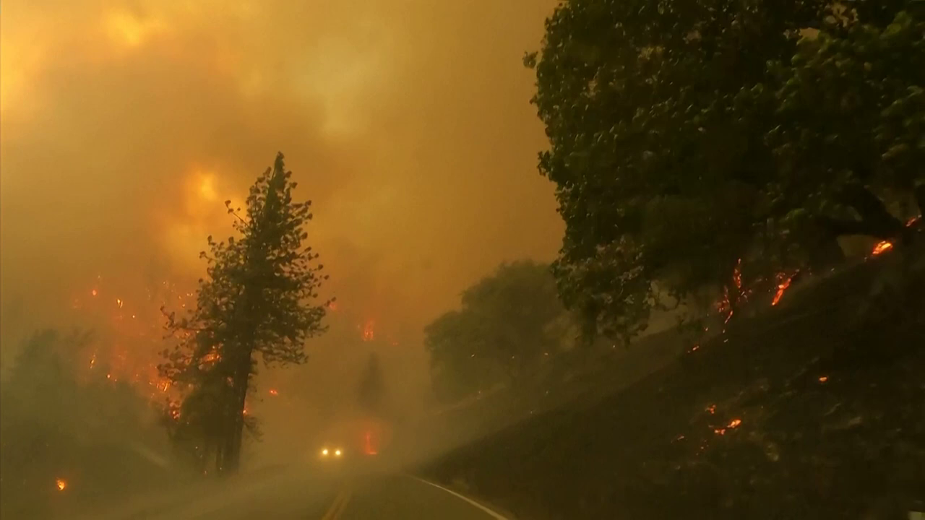

1/1 [==============================] - 0s 228ms/step

Forest fire

pip install twilio

Looking in indexes: https://pypi.org/simple, https://us-python.pkg.dev/colab-wheels/public/simple/

Requirement already satisfied: twilio in /usr/local/lib/python3.7/dist-packages (7.15.2)

Requirement already satisfied: requests>=2.0.0 in /usr/local/lib/python3.7/dist-packages (from twilio) (2.23.0)

Requirement already satisfied: pytz in /usr/local/lib/python3.7/dist-packages (from twilio) (2022.6)

Requirement already satisfied: PyJWT<3.0.0,>=2.0.0 in /usr/local/lib/python3.7/dist-packages (from twilio) (2.6.0)

Requirement already satisfied: chardet<4,>=3.0.2 in /usr/local/lib/python3.7/dist-packages (from requests>=2.0.0->twilio) (3.0.4)

Requirement already satisfied: urllib3!=1.25.0,!=1.25.1,<1.26,>=1.21.1 in /usr/local/lib/python3.7/dist-packages (from requests>=2.0.0->twilio) (1.24.3)

Requirement already satisfied: certifi>=2017.4.17 in /usr/local/lib/python3.7/dist-packages (from requests>=2.0.0->twilio) (2022.9.24)

Requirement already satisfied: idna<3,>=2.5 in /usr/local/lib/python3.7/dist-packages (from requests>=2.0.0->twilio) (2.10)

In [43]:

pip install playsound

Looking in indexes: https://pypi.org/simple, https://us-python.pkg.dev/colab-wheels/public/simple/

Requirement already satisfied: playsound in /usr/local/lib/python3.7/dist-packages (1.3.0)

In [44]:

pip install pygobject

Looking in indexes: https://pypi.org/simple, https://us-python.pkg.dev/colab-wheels/public/simple/

Requirement already satisfied: pygobject in /usr/lib/python3/dist-packages (3.26.1)

In [46]:

**from** twilio.rest **import** Client

**from** playsound **import** playsound

**if** pred**==**0:

print('Forest fire')

account_sid**=**'ACfb4e6d0e7b0d25def63044919f1b96e3'

auth_token**=**'f9ae4fc4a617a527da8672e97eefb2d8'

client**=**Client(account_sid,auth_token)

message**=**client**.**messages \

**.**create(

body**=**'forest fire is detected,stay alert',

*#use twilio free number*

from_**=**'+1 302 248 4366',

*#to number*

to**=**'+91 99400 12164')

print(message**.**sid)

print("Fire detected")

print("SMS Sent!")

**elif** pred**==**1:

print('No danger')

Forest fire

SM71f2cb3eefd74d32b498b392420cec1b

Fire detected

SMS Sent!